We have only one company Alaska Airline that flight in Wenatchee.
Flights from Seattle to Wenatchee and vice versa around November 14-15.

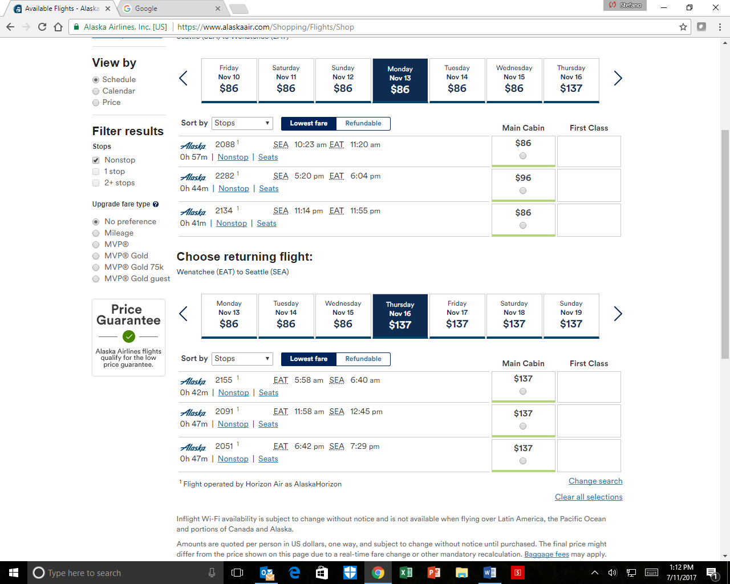
Other possibility
Wenatchee Valley Shuttle: this shuttle will leave the train station of Wenatchee and drop you at the SEA-TAC airport terminal and vice versa. It is a nice alternative.
The Schedule will change at the end of August (August 31). Please check on line for this option at the following web page:
https://www.wenatcheevalleyshuttle.com/schedules

