Our current situation

Just to provide you an example on how we interpret RIMpro forecast and act on it in a practical situation.

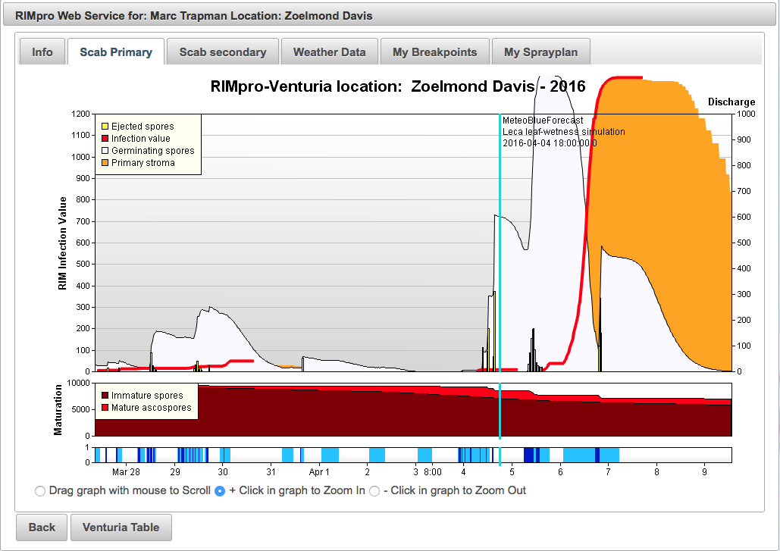

In The Netherlands we are now between mouse ear and green cluster.

Unstill now there have been rain events, but no serious infection events as temperature was low. See e.g. March 28-30. Any preventive cover is enough for this level of infection.

Today April 4th we had rain showers that forced ascospore discharge, and tomorrow April 5th there will be more rain providing another shot of spores.

In-between the apple leaves are dry, but do not stay dry long enough to let all ejected spores die. You see the spores that survive on the apple leaves as the white cloud in the graph. From early morning April 6th onward the germinating spores have developed so fare that they infect the apple leafs. The increasing infection severity is indicated as the red infection line.

This will become a major scab infection.

Our IPM growers are now spraying Captan, the organic growers a low rate of copper (150-200 gram Cu/ha.) to kill the germinating spores on the leafs.

This treatment between start of rain and start of infection, applied even when the leaves are wet, is called treating during the ‘germination window’ and has proven to be very effective.

If the infection becomes as severe as predicted now, we will apply a curative fungicide on April 8 or 8 as well as for these severe infections we do not trust a single protective application to be effective enough.

With kind regards,

Marc